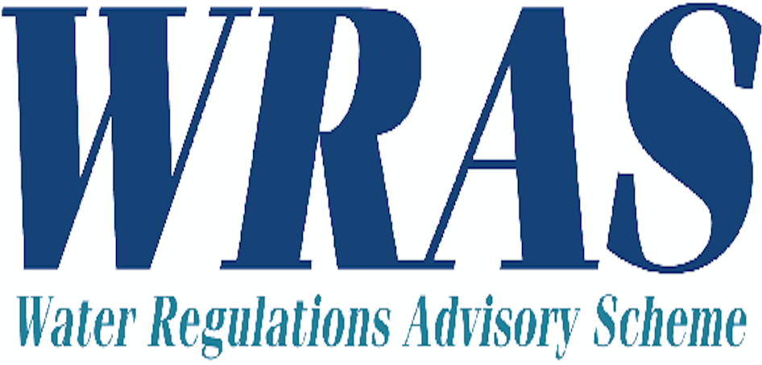

F2 APPLICATION FORM FOR WRAS PRODUCT APPROVAL

The Water Regulations Advisory Scheme approves water fittings and materials that meet the requirements of the Water Supply (Water Fittings) Regulations in England, Wales and Northern Ireland, and The Scottish Water Byelaws 2004.

Water fittings must not waste, misuse, unduly consume or contaminate the water supply.

In order to assess this, fittings are tested against the performance requirements of the Regulators’ Specification and other relevant requirements of the Regulations.

WRAS Approval is granted by representatives of the Water Suppliers to fittings that have been examined and found to fully satisfy the requirements of the Scheme.

The information detailed in this application will be used by the Scheme to produce your approval documentation and directory listing if your application is approved. You are therefore required to confirm the accuracy of all information provided by signing the application form.
It is a requirement that you must notify the Scheme of any changes to the information detailed in this form during the assessment of the product and throughout the period for which the Approval is valid.
All applications for WRAS Approval must include the following: -
(Please tick the boxes below to indicate that you have included all of the information required)

- A completed F2 application form.
(Please ensure you fill in every section indicating ‘not applicable’ if appropriate)
- General assembly drawings of the product and detailed drawings of all components relating to the application.
- Installation manuals, where applicable, for all items relating to the application.
- Photographs of the product and identification marks (This is currently optional)

All applications for WRAS Approval are subject to the Standard Terms and Conditions of WRAS Fittings Approval as amended from time to time (“Standard Terms of Approval”). The current Standard Terms of Approval are available from the WRAS website: www.wras.co.uk

(Please be aware that failure to include any of the items listed above may result in a delay when processing your application.)

In addition to the above requirements product catalogues, product information manuals and other documentation relating to the product should also be submitted.

Official use only
Sample Number
FORM F2

1. | Application category (Please tick one of the boxes below)
 | First application □ | 5 year Audit □ previous approval number
2. | Current manufacturing status of the fitting | Production □ | Pre-production □ | Prototype □
2. | Current manufacturing status of the fitting | Please note pre-production and prototype samples may require audit testing of the production sample before approval is given
3. | Name and address of applicant (“Applicant”)  (Please be aware that unless advised otherwise the company name provided here will be that published on the certificate)  Company name:  Address:  Telephone number:  Fax number:  Company website:  Company email address:
4. | Contact details of the person responsible for this application:  Name:  Company name:  Address:  Email address:  Telephone number:  Mobile number:  Fax: number:  Are you acting as an agent? Please indicate yes□ or no□
5. | Name and address of manufacturer of fitting(s)  Where approval is sought for fittings that are manufactured or assembled at more than one site, please list all of the manufacturing sites or assembly plant addresses.  Company name:  Address:  Should the manufacturer be included on approval? Please indicate yes□ or no□
6. | Contacts /Correspondence  Pre approval application stage  All contact and/or correspondence should be directed toward the person named in:  Please tick as appropriate Section 3 □ or section 4 □ or section 5 □  Post approval  All approval documentation should be sent for the attention of the person named, at the address given, in:  Please tick as appropriate Section 3 □ or section 4 □ or section 5 □  Any other correspondence, including any reminders that the approval is due to expire (audit/reminder letter), will be directed to the `Applicant` named in section 3.
7. | Fitting(s) name(s)  Please state all model numbers/product names/product codes for which approval is sought  (Please note that the information provided here will form the basis of any subsequent approval documentation, the scheme does not grant approvals for generic model names i.e. Brass compression fitting)
8. | Type of the water fitting for which approval is sought  Please state the generic product type e.g. Washing Machine, Gate Valve, WC etc.
9.) | Description of markings present on fitting:  Location of marking, e.g. on valve body, on adhesive label on cover:  Please indicate whether any of the marking is likely to change during the lifetime of the approval, e.g. date of manufacture or cast or ID numbers:
10.) | Mechanical Characteristics
Maximum working pressure (if applicable) bar

Maximum operating temperature (if applicable) ºC

For fittings that have a range of maximum working pressures please include additional details below. (For example plastics plumbing pipes for hot and cold water use might be:
12.5 bar @ 20 ºC, 6 bar @ 95 ºC, 3 bar @ 105 ºC )

DECLARATION

I / We, the Applicant named in section 3 of this Form F2, declare as follows:

- I/we have read and understand and accept the terms applicable to applications for WRAS Approval as set out in the Standard Terms of Approval;

- I/we confirm that where WRAS Material Approval numbers or BS6920 test reports are referenced in this application, the material used remains identical to those material(s) tested in the supporting documentation or previously approved by WRAS. No ingredients have been added, directly or indirectly during the manufacturing process and the material has not been modified in any way.

- Unless otherwise indicated in the Schedule of Materials set out in Appendix A of this Form F2, I/we confirm that where a component is manufactured from Polyphenyleneoxide (PPO), Polyphenylene Ether (PPE) or Polyoxymethylene (POM), the component has a wetted surface area of less than 3,000mm².

- I/we warrant the accuracy and completeness of all information contained in this Form F2 and any other information now or subsequently provided by me/us and/or our Agents to WRAS and/or the relevant test facility in pursuance of this application and confirm that none of this information is or may be construed as misleading in any way.

- The Agent whose details are set out in section 4 of this Form F2 is duly authorised to represent and answer all queries on behalf of the Applicant in relation to this application. I/we, the Applicant, agree to ratify all acts and omissions of the Agent in connection with this application and to indemnify WRAS for any losses incurred as a result of any breach of the Standard Terms of Approval by the Applicant and/or our Agent(s).

Signed:…………………………….………………………Name:………...………………………………..……………
The Applicant (Director or other authorised employee of the applicant)

Date:…………..………………………………

Important Note: This declaration must be signed by the Applicant (ideally a director in the company) and must not be signed by the Agent on behalf of the Applicant.

Please return completed applications to your chosen Test House Facility, contact details below:

Kiwa Ltd,  (Watertec Trading Division)  26a Rassau Industrial Estate,  Rassau,  Ebbw Vale,  Gwent,  NP23 5SD,  UK  +44 (0) 1495 308 185  david.jay@kiwa.co.uk | NSF-WRc.  Fern Close,  Pen-y-Fan Industrial Estate,  Oakdale,  Gwent,  NP11 3EH,  UK  +44 (0) 1495 236 260  wras-approvals@nsf.org

Please note: additional copies of this form can be downloaded from the WRAS website www.wras.co.uk

Official use only
Sample Number

APPENDIX A– SCHEDULE OF MATERIALS
Please list all parts of the fitting, both metallic and non-metallic, that will come into contact with wholesome water.
(Note: Please include all lubricants/adhesives/jointing compounds/tapes that are used during assembly)

MODEL AND DRAWING NO:

Item number on drawing | General description of item including material of manufacture (e.g. spring or O-ring). | Manufacturer of material or component. | Tradename & type of the material, including grade, colour and shore hardness where applicable (e.g. EPDM 123). | WRAS approval number or included BS 6920 test report reference. | Manufacturing process (please detail the process used to make the component e.g. injection moulding).

Signed:…………………………….………………………Name:………...………………………………..…………………..Date………………………………
The person who signs the F2 declaration must sign all pages of Appendix A

Official use only
Sample Number

APPENDIX A – SCHEDULE OF MATERIALS CONTINUED

MODEL AND DRAWING NO:

Item number on drawing | General description of item including material of manufacture (e.g. spring or O-ring). | Manufacturer of material or component. |  | Tradename & type of material, including grade, colour and shore hardness where applicable (e.g. EPDM 123). | WRAS approval number or included BS 6920 test report reference. | Manufacturing process (please detail the process used to make the component e.g. injection moulded).

Signed:…………………………….………………………Name:………...………………………………..…………………..Date………………………………
The person who signs the F2 declaration must sign all pages of Appendix A

Official use only
Sample Number

APPENDIX A – SCHEDULE OF MATERIALS CONTINUED

MODEL AND DRAWING NO:

Item number on drawing | General description of item including material of manufacture (e.g. spring or O-ring). | Manufacturer of material or component. |  | Tradename & type of material, including grade, colour and shore hardness where applicable (e.g. EPDM 123). | WRAS approval number or included BS 6920 test report reference. | Manufacturing process (please detail the process used to make the component e.g. injection moulded).

Signed:…………………………….………………………Name:………...………………………………..…………………..Date………………………………
The person who signs the F2 declaration must sign all pages of Appendix A

