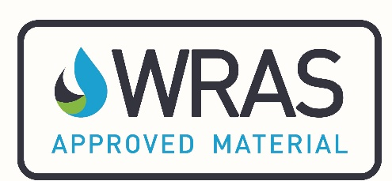

M3 - APPLICATION FOR A MATERIAL SECONDARY APPROVAL

An approval may be granted, without the need for further testing, where it can be demonstrated that the secondary product/s is/are identical to the primary product/s that possess an existing approval.
Such products are usually re-branded and sold by a ‘factor’ or retailer

Primary/existing approval holder refers to the company that already possesses the approval.
Secondary applicant refers to the company applying for approval.

* Important * Please be aware that the information detailed in this application will be used by the Scheme to produce your approval documentation and directory listing should your application be successful. Therefore the Scheme must be notified of any changes to the information detailed in this form.

1. | Primary approval/listing number:
2. | Details of primary/existing approval holder
2. | Name of company:
2. | Address of company:
3. | Details of secondary applicant
3. | Name of company:
3. | Address of company:
3. | Telephone number of company:
3. | E-mail address of company:
4. | Contact details of the individual responsible for this application
4. | Name:
4. | E-mail address:
4. | Telephone number:
5. | Permission from the primary approval holder is required. This section must be completed by the primary approval holder
5. | I give permission, on behalf of the primary approval holder, for the secondary company (whose details appear below) to apply for a secondary approval. I declare that the secondary products are identical to the primary products in the following respects: formulation, suppliers of raw ingredients and site & method of manufacture.
5. | Primary approval holder company name:
5. | Primary approval holder company address:
5. | Secondary/applicant company name:
5. | Name and e-mail address:
5. | Position in company:
5. | Signature:
5. | Date:
6. | The secondary applicant is required to declare that the products are identical. This section must be completed by the secondary approval applicant
6. | I declare, on behalf of the secondary applicant, that the secondary products are identical to the primary products in the following respects: formulation, suppliers of raw ingredients and site & method of manufacture.
  Name/s of primary product/s | Name/s of secondary product/s
6. | Name and e-mail address:
6. | Position in company:
6. | Signature:
6. | Date:

Note: Please forward the completed application to info@wrasapprovals.co.uk.

