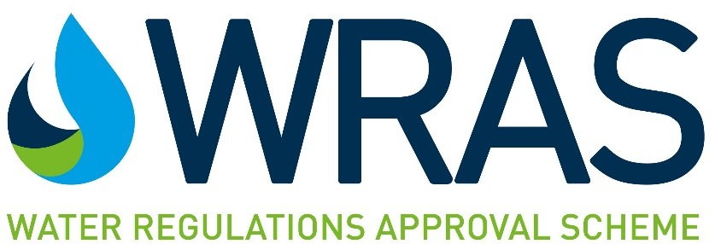

|  |  |
| --- | --- |
| **OFFICIAL USE ONLY** | |
| Authorised |  |
| Date: |  |
| Marking |  |
| Application type: | Choose an item. |

**F3 - APPLICATION FOR A SECONDARY PRODUCT APPROVAL**

An approval may be granted, without the need for further testing, where it can be demonstrated that the secondary product/s is/are identical to the primary product/s that possess an existing approval.

Such products are usually re-branded and sold by a ‘factor’ or retailer.

Primary/existing approval holder refers to the company that already possesses the approval.

Secondary applicant refers to the company applying for approval.

***\* Important * Please be aware that the information detailed in this application will be used by the Scheme to produce your approval documentation and directory listing should your application be successful. Therefore, the Scheme must be notified of any changes to the information detailed in this form****.*

|  |  |  |
| --- | --- | --- |
| 1. | **PRIMARY APPROVAL/LISTING NUMBER:** |  |
| 2. | **DETAILS OF PRIMARY/EXISTING APPROVAL HOLDER** | |
| Name of company: |  |
| Address of company: |  |
| 3. | **DETAILS OF SECONDARY APPLICANT** | |
| Name of company: |  |
| Address of company: |  |
| Telephone number of company: |  |
| E-mail address of company: |  |
| 4. | **CONTACT DETAILS OF THE INDIVIDUAL RESPONSIBLE FOR THIS APPLICATION**  *NOTE****:*** *Approval documents will be sent to the person named in this section unless otherwise instructed*. | |
| Name: |  |
| Company: |  |
| E-mail address: |  |
| Telephone number: |  |

|  |  |  |
| --- | --- | --- |
| 5. | **PERMISSION FROM THE PRIMARY APPROVAL HOLDER IS REQUIRED.**  *THIS SECTION MUST BE COMPLETED BY THE PRIMARY APPROVAL HOLDER* | |
| Primary approval holder company name: |  |
| Primary approval holder company address: |  |
| Secondary/applicant company name: |  |
| Name and e-mail address: |  |
| Position in company: |  |
| I give permission, on behalf of the primary approval holder, for the secondary company (whose details appear below) to apply for a secondary approval. I declare that the secondary products are identical to the primary products in the following respects: water pathways, materials of construction and site & method of manufacture. | |
| Signature: |  |
| Date: |  |
| 6. | **DESCRIPTION OF PERMANENT MARKINGS PRESENT ON FITTING, E.G. COMPANY LOGO**  **Will the marking on the product be different to that on the Primary Approved Product?** YES NO  If “Yes” include details of the marking and its location below, or as an attachment.  If this is your company Trademark /logo, do you give permission for this to be placed in the public domain on the WRAS website? YESor NO  **Indicate whether any of the marking is likely to change during the lifetime of the approval, e.g. date of manufacture or cast or ID numbers:** | |

|  |  |  |
| --- | --- | --- |
| 7. | **THE SECONDARY APPLICANT IS REQUIRED TO DECLARE THAT THEY WILL CONTACT WRAS IF ANY MODIFICATIONS ARE MADE TO THE SECONDARY PRODUCTS.**  *THIS SECTION* ***MUST*** *BE COMPLETED BY THE SECONDARY APPLICANT:* | |
| |  |  | | --- | --- | | Model name/s of primary products | Model name/s of secondary products | |  |  | |  |  | |  |  | |  |  | |  |  | |  |  | |  |  |   WRAS may request physical samples to complete the application for a secondary approval. If this is the case, once WRAS have finished with the samples they will kept for a period of 10 days. If required, the collection of samples must be arranged by the applicant. Please note, that it may be necessary for WRAS to dismantle samples for inspection/verification, in some instances this is not possible without damage to the product which WRAS accepts no responsibility for. If neither box below is ticked, or collection is not arranged within 10 days of the approval documents being issued, the samples will be disposed of by WRAS.  Any samples requested by WRAS can be disposed of by WRAS □  Any samples requested by WRAS will be collected at our cost within 10 days of notification □  Please note all delivery charges, which includes but not restricted to import duty and taxes must be paid by the sender. If WRAS is invoiced for any charges resulting from parcels received, an additional administration fee of £75.00 (plus VAT where applicable) will be applied to the invoice amount and charged to the sender. | |
| Name and e-mail address: |  |
| Position in company: |  |
| I declare that no modifications to the products named above have been made.  All applications for WRAS Approval are subject to the Standard Terms and Conditions of WRAS Product Approval as amended from time to time (Standard Terms of Approval). The current Standard Terms of Approval are available from the WRAS Website [www.wrasapprovals.co.uk.](http://www.wrasapprovals.co.uk.)  **I/We have read, understand, and accept the terms applicable to applications for WRAS Approval as set out on the Standard Terms of Approval and agree to the terms of payment.** | |
| Signature: |  |
| Date: |  |

|  |  |  |
| --- | --- | --- |
| 8 | **INVOICING INFORMATION**  *THIS SECTION MUST BE COMPLETED BY THE APPLICANT’S ACCOUNTS DEPARTMENT* | |
| NOTE: Completion of this section does not guarantee an approval will be granted.  An invoice will be issued when the application has been processed.  NOTE: When making payments please include either the WRAS approval number(s) or the WRAS invoice number as a reference against the payment to ensure our accounts department can allocate the payment correctly | Terms:  1. Payment to be within 30 days from date of invoice  2. All payments should be made in great British Pounds Sterling  3. Any bank charges incurred (including currency conversion) must be paid by the vendor. WRAS will not accept charges.  FAILURE TO ADHERE TO THESE TERMS WILL RESULT IN WITHDRAWAL OF THE APPROVAL |
| ACCOUNTS DEPARTMENT CONTACT NAME: (if invoice is to be issued to a different person to the Responsible Person named above) |  |
| Email ADDRESS: |  |
| TELEPHONE: |  |
| Company Name & Address to appear on Invoice ( If different to above) |  |
| PURCHASE ORDER NUMBER (where applicable): |  |
| COMPANY VAT NUMBER (where applicable): |  |

Please forward the completed application to [info@wrasapprovals.co.uk](mailto:info@wrasapprovals.co.uk).

|  |  |  |  |
| --- | --- | --- | --- |
| **FOR WRAS USE ONLY:** |  | |  |
| WRAS Approval: | | |
| **COST:**Choose an item. | | **VAT Choose: :** | **TOTAL:** |